“Exploring Graduate Studies at the


Interface of Engineering and the Life Sciences”
University of Massachusetts Amherst
November 7-9, 2008

The University of Massachusetts Amherst Northeast Alliance for Graduate Education and the Professoriate (NEAGEP), Institute for Cellular Engineering (ICE) and College of Engineering are thrilled by your interest in our Fall Graduate Preview Event! Program highlights are outlined below.
Come and learn about Graduate Study opportunities at UMass Amherst!
Friday, November 7, 2008: Welcome Reception

Saturday, November 8, 2008: UMass Graduate Preview
A variety of activities are planned to introduce you to the UMass Graduate Student Experience
8:00 AM – 9:00 AM: Continental Breakfast
9:15 AM – 9:30 AM: Welcoming remarks
9:30 AM – 10:15 AM: “Opportunities for Interdisciplinary Graduate Training at UMass”
Professor Susan Roberts, Director of the Institute for Cellular Engineering
10:15 AM – 10:30 AM: Break
10:30 AM – 11:30 AM: “The UMass Graduate Student Experience”
UMass Amherst Graduate Student Panel
11:30 AM – 12:00 PM Interdisciplinary Program Meet–and–Greet
12:00 PM – 1:30 PM Complimentary Faculty/Student Luncheon
Graduate Student Poster Session
1:30 PM – 2:30 PM “Experiences at UMass Amherst and Beyond”
UMass Amherst Alumni Panel
2:30 PM – 3:00 PM “Applying to UMass Graduate School”
Michael Alderman, UMass Graduate School
3:00 PM – 3:15 PM Break
3:00 PM – 4:45 PM Laboratory Tours: Cutting-edge Cellular Engineering Facilities
Dinner Social Event, Downtown Amherst
Sunday, November 8, 2008: Farewell breakfast

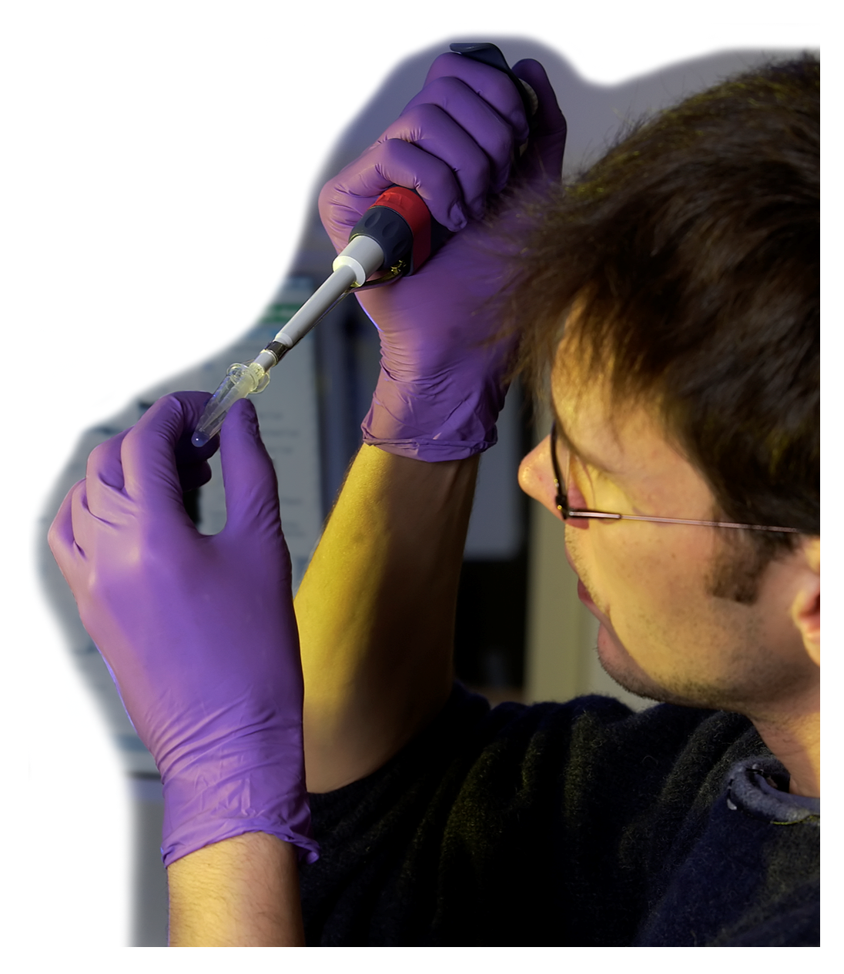

Don’t let distance be an obstacle! NEAGEP-sponsored travel awards cover transportation, lodging and meal expenses for the weekend of November 7-9, 2008. To be considered, please return the attached application and all supporting materials to Marlina Duncan by Friday, October 17th.

Marlina Duncan
NEAGEP Program Director
University of Massachusetts, Amherst
524 Goodell Building
Amherst, MA 01003

Email: mduncan@educ.umass.edu
Website: www.neagep.org
Phone: 413.577.2481

APPLICATION: NEAGEP Travel Award, November 7-9, 2008

participant information
Last Name |  |  |  |  |  |  |  |  |  | First Name |  |  |  |  |  |  |  |  |  |  |  |  |  | Middle Initial
Current Address |  |  |  |  |  |  |  |  |  |  |  |  | Phone
City, State, Zip |  |  |  |  |  |  |  |  |  |  |  |  | Email
Permanent Address |  |  |  |  |  |  |  |  |  |  |  |  | Phone
City, State, Zip |  |  |  |  |  |  |  |  |  |  |  |  | Email
Citizenship | U.S. Citizen |  |  | Legal Permanent Resident
Race/Ethnicity | Black/African American |  |  |  |  | American Indian/Alaskan |  |  |  |  | Asian |  |  |  |  | Pacific Islander |  |  |  |  |  | Latino/Hispanic |  |  | White
Do you have a disability? |  | Yes |  |  | No |  | If yes, please specify
Gender |  | Male |  |  | Female |  |  |  |  |  |  |  | Date of Birth

academic information
Undergraduate University |  |  |  |  |  |  |  |  |  |  |  |  |  | Graduation Date
Current Class | Freshman |  |  |  | Sophomore |  |  |  | Junior |  |  |  |  |  | Senior |  |  |  |  |  | Already graduated
Undergrad Major(s) |  |  |  |  |  |  |  |  |  |  |  |  |  |  |  |  |  |  | GPA
Which graduate degree(s) are you interested in pursuing? |  |  |  |  |  |  |  | Masters |  |  |  |  | Doctoral |  |  |  |  |  | Undecided
If yes, which departments are you interested in? (check all that apply)
Biochemistry & Molecular Biology  Biology  Chemical Engineering  Chemistry  Computer Science  Mechanical & Industrial Engineering  Microbiology |  |  |  |  |  |  |  | Molecular & Cellular Biology Interdisciplinary Graduate Program  Neuroscience & Behavior Interdisciplinary Graduate Program  Organismic & Evolutionary Biology Interdisciplinary Graduate Program  Plant Biology Interdisciplinary Graduate Program  Physics  Polymer Science & Engineering  Veterinary & Animal Sciences  Other: Please specify

honors
Please list any honors you have received, such as scholarships, fellowships, election to honor societies, etc.

research experience
Please list any research experience you might have (independent study, summer research, etc.).

faculty recommendation
Which faculty member will be providing your letter of recommendation?
Name
Title/Position
Email |  |  |  |  |  |  |  |  |  |  |  | Phone Number

How did you learn about this Event?
Please tell us how you learned about this event (websites, direct email from program, email from friend, email from professor, etc.)

PERSONAL STATEMENT
Please tell us a little bit about yourself. Suggested topics include: Why does this program interest you? What are your plans for graduate study, and your career aspirations? (Please limit responses to one full page).
Supporting materials: In addition to the above application, return the following to Marlina Duncan:
- An unofficial transcript.
- One letter of reference from a faculty member who can comment on your potential for academic research.

