University of Massachusetts Boston June 25, 2010 Department of Chemistry

Chemistry Doctoral Program

Green Chemistry Track

**Written Qualifying Exam**

**Inorganic Chemistry**

Questions are based on the following article:

Grubel K, Rudzka K, Arif AM, Klotz KL, Halfen JA, Berreau LM. Synthesis, Characterization, and Ligand Exchange Reactivity of a Series of First Row Divalent Metal 3-Hydroxyflavonolate Complexes *Inorganic Chemistry* 49: 82-96, **2010**.

1. What are the *quercentinases*? Write a general scheme for the reaction they catalyze. Explain the possible roles for the metal center(s). *(3 points)*
2. Assign the 1H NMR signals to the structure shown below. Explain briefly the chemical shifts and the splitting patterns. *(3 points)*





1. [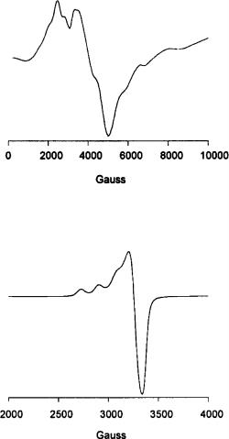](http://pubs.acs.org/action/showImage?doi=10.1021/ic901405h&iName=master.img-005.png&type=master)The authors applied EPR spectroscopy for structural studies of Mn(II) and Cu(II) complexes of 1-OTf and 4-OTf. How is an EPR spectrum obtained in general? What spectral parameters were used here for analysis?

(*2 points*)

1. How were the redox properties investigated? What factors influence the oxidation potential of the flavonolate ligand and what are the consequences? *(2 points)*
2. ***(Green Chemistry Question)*** Free radicals, including the unstable forms of oxygen referred to as reactive oxygen species (ROS), can form in the body as natural byproducts of metabolic redox reactions or in response to environmental stress (e.g. radiation, pollution). The cellular damage caused by ROS has been implicated in the aging process and numerous human diseases as well. Therefore, quercetin and other flavonoids are currently of considerable interest for their *antioxidant* properties. Explain this property based on the general chemical structure of flavonoids. *(2 points)*